This project will show all the EV chargers across Australia. User will be able to find charging points according to their port type, They will also be able to see the cost of charging, the number of ports and the provider. These will help a user to plan their journey accordingly.

1. The dataset I had, did have all the properties I needed except the addresses. I had the coordinates. So first thing I had to do was to convert the coordinates into addresses. I have used reverse geopandas for that:

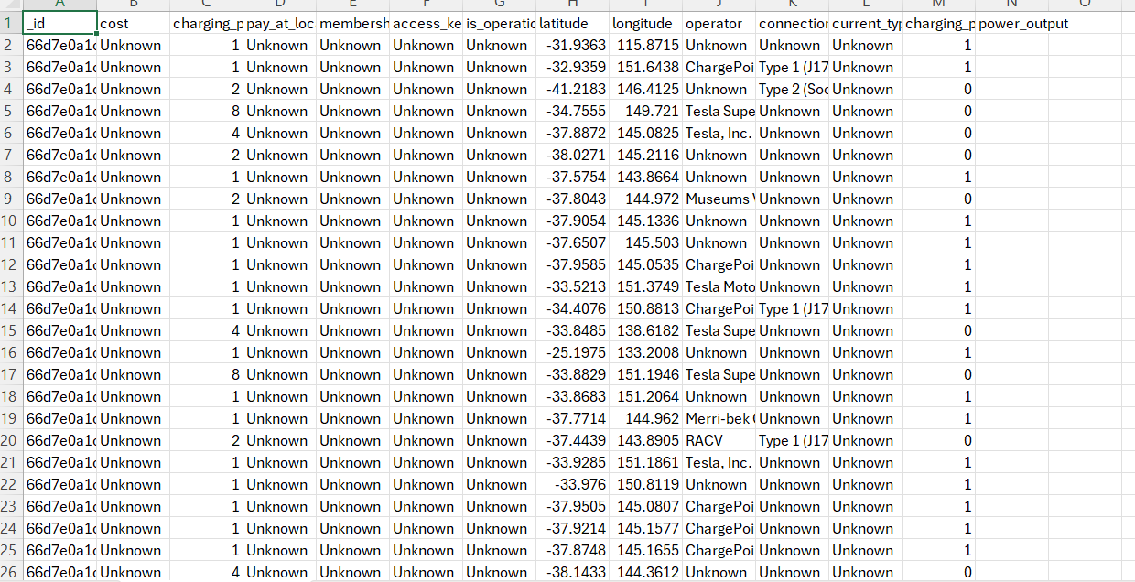

Figure : Before

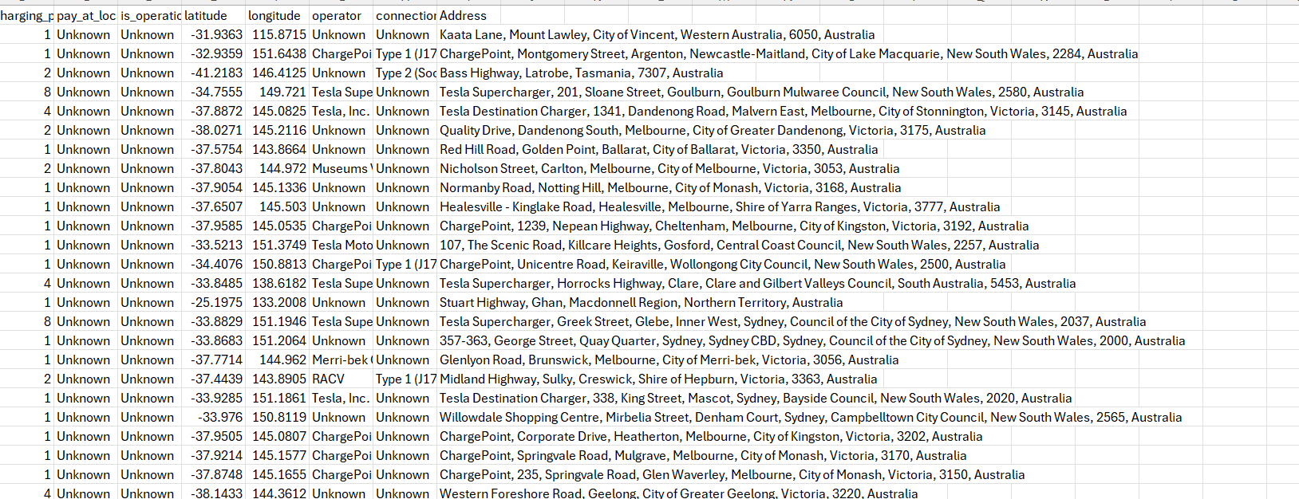

Figure : After

1. Next step was to draw a map and put pointer to all the locations that is in the dataset. To draw the map and put pointer on it I have used folium which I found very useful. After pointing all the coordinates I converted it to a html file. Which looks like this:

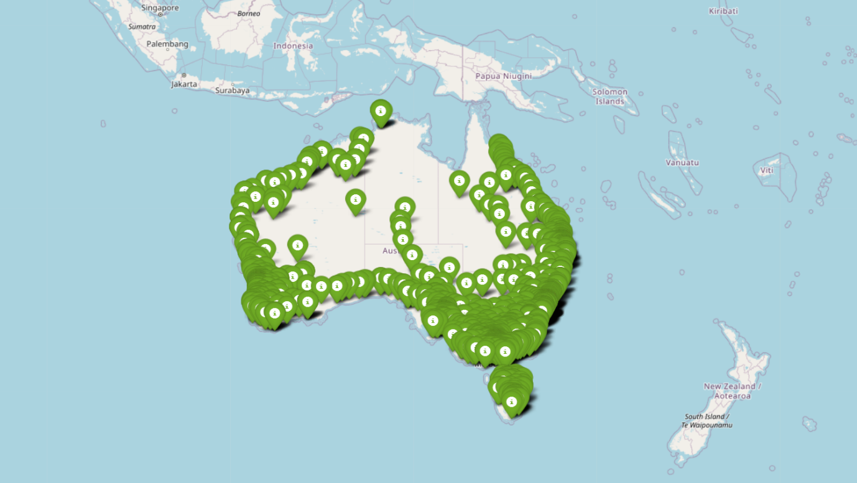

1. I have also added some attributes to each pointer where the user can see the port type, how many ports are there, the cost and the provider

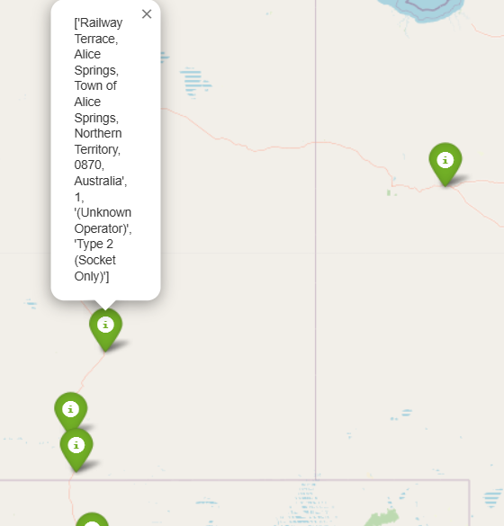

1. Next step was to find the closest charging station . For that I used geocoder.ip to find my coordinates. What this does is, fetch the current location based on the ip.
2. Compare the distance between all the charging stations with my coordinates and draw a route towards the nearest one. I got my api key from openrouteservice and then draw a route between my location and the nearest charging point. This is how it looks like :

